

American International University-Bangladesh (AIUB)
Department of Computer Science Faculty of Science & Technology (FST)
PROJECT TITLE
Community Problem Reporter and Priority Analyzer
Submitted By Group 7
Semester-->Summer-25-26 |  | Section:T
SL | Student Name | Student ID
29 | 24-58655-2 | Sheikh Ahnaful Islam
31 | 24-58796-2 | Ayon Chowdhury
22 | 24-58220-2 | MD. Mezbah-Ul-Hossain Rahat
4 | 23-53306-3 | Md Rashed Musharof
3 | 23-52565-2 | Sabit Haan

1 . Project Proposal
1.1 Background to the Problem
Urban and semi-urban communities across Bangladesh deal with a wide range of recurring infrastructural and civic problems on a daily basis: cracked and waterlogged roads, choked drainage lines, non-functioning street lamps, uncollected waste, and damaged footpaths, among others, all of which directly affect public safety, health, and daily mobility. Municipal bodies such as City Corporations, Pourashavas, and Union Parishads are formally responsible for addressing these issues, but the channels through which citizens can bring problems to their attention remain fragmented and largely informal.
At present, a resident who notices a broken drain cover or a collapsed section of road has few structured options. They may call a ward office, submit a written complaint in person, or, increasingly, post a photo to a community Facebook group and tag the relevant authority. None of these channels are linked to one another, none produce a traceable record, and none allow the citizen to check whether a report was received, is under review, or has been resolved. The result is a communication gap: the same problem is often reported repeatedly through different, disconnected means, while the responsible authority has no single, organized view of what actually needs attention.
This gap is compounded by a second, less visible problem: prioritization. Even where a complaint register or hotline exists, requests are generally handled in the order received rather than by actual urgency or community impact. A minor but visible issue on a well-travelled road may be fixed quickly simply because it draws attention, while a genuinely hazardous problem in a quieter residential lane can remain unresolved for months, since no mechanism exists to weigh its severity against the volume of other pending reports. Limited budgets and field staff make this worse: without a reliable way to rank issues, resources are often allocated reactively rather than to where they matter most.
The Community Problem Reporter and Priority Analyzer is proposed as a response to both halves of this problem. It gives citizens a single web-based channel to report an issue with a category, description, photo, and location, and lets other residents endorse reports that affect them too. Rather than leaving prioritization to guesswork, the system calculates a priority score for each report from a combination of factors, how severe the issue is, how much community support it has received, and how long it has been outstanding, so that authorities are presented with an objectively ranked list of what needs attention first. In effect, the platform turns scattered, one-off complaints into a shared, continuously updated picture of a community's infrastructure needs.
This kind of platform also sits within a broader shift toward digital public service delivery. As smartphone and internet access continue to expand beyond major cities in Bangladesh, web-based tools are becoming a realistic way to connect citizens directly with local government, rather than routing every interaction through in-person visits or informal channels. A structured reporting and prioritization system offers municipal authorities a low-cost way to become more transparent and responsive, while giving residents visible evidence that their concerns are being tracked rather than lost.

1.2 Target Users of the System
The system is designed for three direct user groups, each with different needs and a different level of technical familiarity.
Citizens / Residents form the largest and most diverse user group, spanning a wide range of ages, occupations, and levels of digital literacy. Most will access the platform from a smartphone rather than a desktop computer, so ease of use matters more than feature depth for this group: reporting a problem should take only a couple of minutes, rely mainly on photos and simple category choices, and require minimal typing. This group also drives the voting feature, giving the system a way to measure community impact that a single report cannot convey on its own.
Local Authorities are ward-level officials, engineers, and department staff at bodies such as City Corporations, Pourashavas, and Union Parishads, who are responsible for resolving reported issues. Unlike citizens, this group needs a structured dashboard: a ranked list of open problems, the ability to filter by category or location, and a simple way to update a report's status as work progresses. Their priority is being able to manage a growing volume of reports efficiently, and to justify prioritization decisions to residents or supervisors when needed.
Administrators are a smaller, internal group responsible for the platform itself rather than for any individual report, managing user accounts, maintaining problem categories, monitoring for spam or misuse, and keeping the system running smoothly. Although they interact with the system least often of the three groups, their role is essential to keeping the platform trustworthy and usable for everyone else.
Beyond these three groups, the data the system collects has secondary value: community organizations, local journalists, and urban planners could draw on aggregated, location-tagged reports to identify where infrastructure investment is most needed, even though the platform is not designed around their use in its initial scope. Taken together, these user groups frame the problem this project addresses: not a lack of willingness among citizens to report issues, but the absence of a structured, transparent, and fairly prioritized channel connecting them with the authorities responsible for acting on their behalf.

1.3 Selection of Process Model

Selected Process Model: Dynamic Systems Development Method (DSDM)

Overview of the DSDM Model
The Dynamic Systems Development Method (DSDM) is an Agile software development framework that focuses on rapid delivery, active user involvement, and iterative development. It ensures that high-priority features are delivered first while maintaining quality and meeting deadlines.
DSDM follows a structured lifecycle where the system is developed incrementally. Each iteration produces a functional part of the system, allowing continuous feedback and improvement.
The model is particularly suitable for projects that require flexibility, user interaction, and privatization of features

DSDM Process Visualization
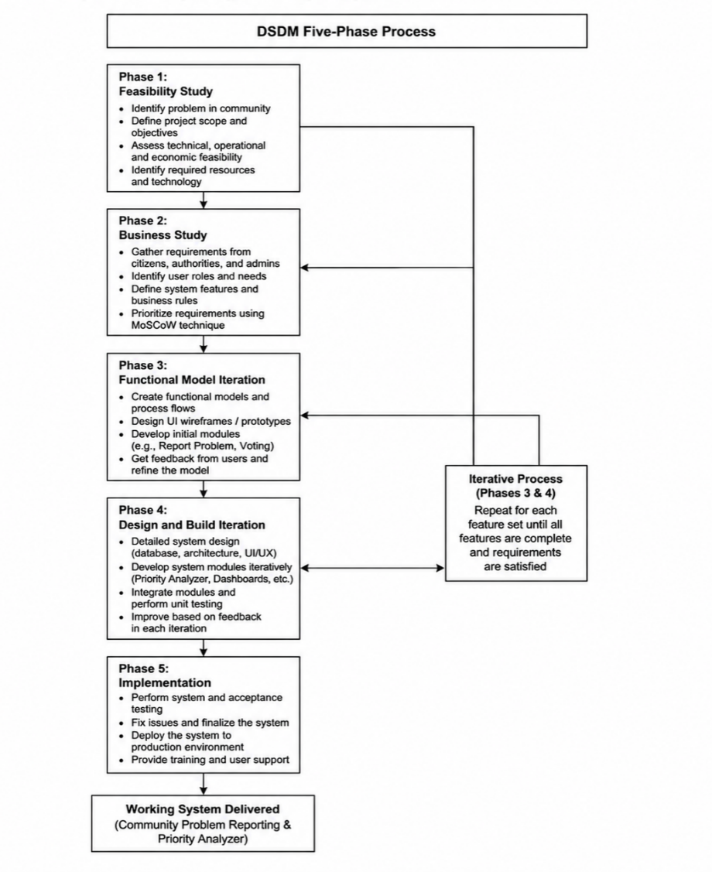

Explanation of DSDM Phases

1. Feasibility Study
In this phase, the overall feasibility of the project is analyzed.
- Identify the problem of inefficient complaint systems
- Define project scope
- Check technical feasibility (web system, database, UI)

2. Business Study
This phase focuses on understanding user requirements and business needs.
- Identify user roles (Citizen, Authority, Admin)
- Define system features (report problem, vote, priority system)
- Understand how users interact with the system

3. Functional Model Iteration
In this phase, prototypes and initial models are developed.
- Design UI wireframes
- Create basic reporting system
- Collect feedback and improve design
4. Design and Build Iteration
This is the core development phase.
- Develop frontend (UI pages)
- Implement back-end logic (Priority Analyzer)
- Integrate database and system modules

5. Implementation
Final system is deployed and tested.
- System deployment
- Final testing
- User access and usage

Why We Chose DSDM for This Project
The DSDM model is selected for the Community Problem Reporting and Priority Analyzer system due to the following reasons:

1. Supports Priority-Based System
The system includes a Priority Analyzer that ranks problems based on importance.
DSDM uses the MoSCoW prioritization technique, which perfectly aligns with this concept. It allows the development team to focus on the most critical features first.

2. Iterative Development of Features
The project contains multiple modules such as:
- Problem Reporting
- Voting System
- Priority Analyzer
- Dashboard Systems
- DSDM allows these features to be developed step by step, ensuring better control and quality.
3. Strong User Involvement
- The system depends heavily on user interaction:
- Citizens report and vote
- Authorities manage problems
- Admin controls the system
4. Timeboxing Ensures Timely Delivery
- Each phase in DSDM is time-limited, which helps:
- Maintain deadlines
- Avoid delays
- Deliver features on time

5. Continuous Testing and Quality Assurance
Each iteration includes testing, which helps:
- Identify errors early
- Improve system reliability
- Ensure accurate priority calculation

6. Reduced Risk
Since development is incremental:
- Problems in one feature do not affect the whole system
- Core features can be delivered even if advanced features are delayed

7. Future Scalability
The system can be expanded with new features such as:
- Mobile application
- Advanced analytics
- AI-based solutions
DSDM supports easy integration of future features.
The DSDM process model is the most suitable choice for this project because it supports prioritization, iterative development, and user involvement. It ensures timely delivery, high-quality output, and a flexible development approach, making it ideal for building the Community Problem Reporting and Priority Analyzer system.

2 . Timeline Chart / Gant
MD RASHED MUSHAROF: https://trello.com/invite/b/6a9038564629504848073a28/ATTI0211e... | Chat | Microsoft Teams

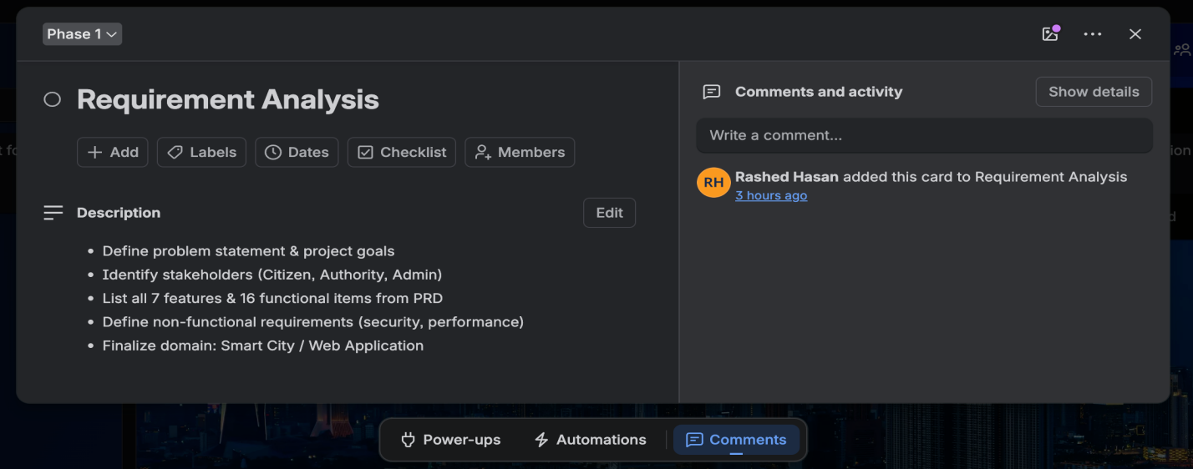
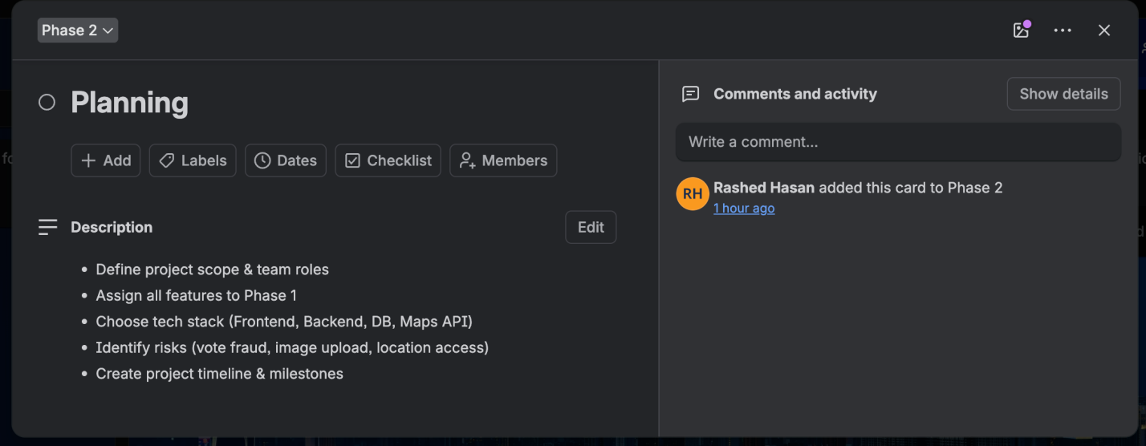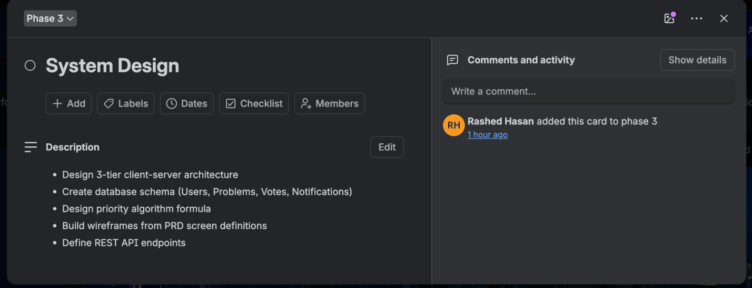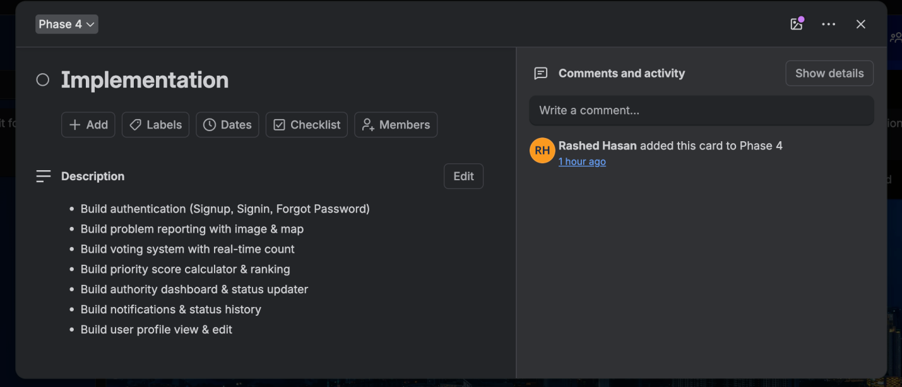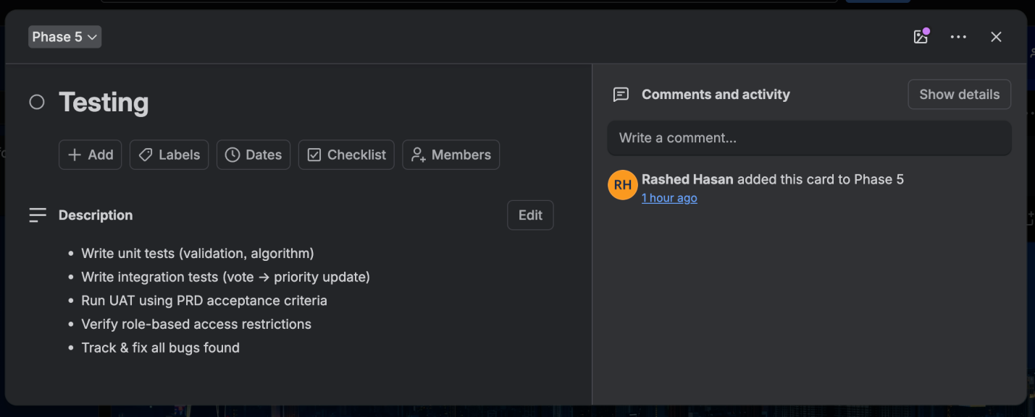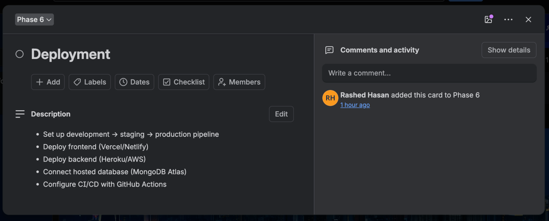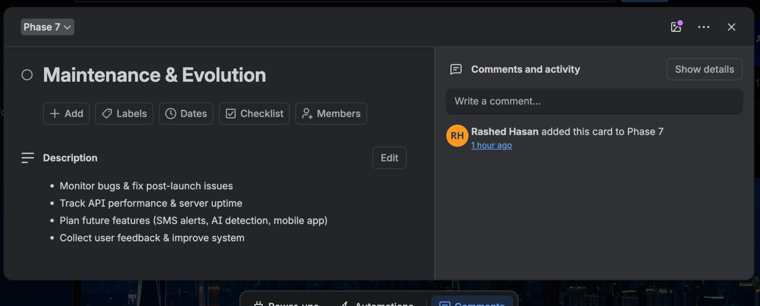
3. SOFTWARE REQUIREMENTS SPECIFICATION (SRS) / PRD

3.1 Scopes and Features (Functional)
The Community Problem Reporting & Priority Analyzer is a web application that enables citizens to report local infrastructure issues, vote on existing reports, and track resolution progress. Authorities can view prioritized problem lists and update statuses. The platform serves three access roles: Citizen, Authority, and Admin.

Feature ID | Feature Name | -Features / Screens Sub
F1 | User Authentication | Sign up | Sign in | Forgot Password
F2 | Problem Reporting System | Report Problem | View Submitted Problems
F3 | Citizen Voting System | Vote on Problem | View Vote Count
F4 | Priority Analyzer | Calculate Priority Score | Rank Problems by Priority | Display High Priority Problems
F5 | Authority Dashboard | View All Reported Problems | Update Problem Status
F6 | Problem Status Tracking | View Problem Status Details | Receive Status Updates
F7 | User Profile Management | View Profile | Edit Profile

Access Roles
- Citizen (User) – Reports problems, votes, tracks status, manages profile.
- Authority – Views all reports, updates problem status, accesses priority dashboard.
- Admin – Manages users, monitors system activity, oversees all data.

3.2User Story Table-
User | Wants To | So That

Citizen | As a Citizen, I want to register an account with my name, email, phone number, and password | So that I can access the Community Problem Reporter platform.

Citizen | As a Citizen, I want to report a local problem by providing a title, description, category, severity, image, and location | So that the relevant authorities are informed about the issue.

Citizen | As a Citizen, I want to view a list of my submitted reports | So that I can track the problems I have reported.

Citizen | As a Citizen, I want to up-vote problems reported by others | So that urgent community issues receive higher priority.

Citizen | As a Citizen, I want to view the details and status history of my reported problems | So that I can monitor the progress of their resolution.

Citizen | As a Citizen, I want to receive notifications whenever the status of my report changes | So that I stay informed about updates.

Citizen | As a Citizen, I want to sign in securely using my email and password | So that I can report and track community problems.

Citizen | As a Citizen, I want to reset my password if I forget it | So that I can regain access to my account securely.

Citizen | As an Citizen, I want to view the vote count on each reported problem | So that I know how many people are affected by the issue.

Citizen | As anCitizen, I want to view my profile information, including my name, email, phone number, and total reports submitted | So that I can monitor my account activity.

Citizen | As an Citizen, I want to edit my profile information | So that my account details remain up to date.

Authority | As an Authority, I want to view problems ranked by priority score | So that I can address the most critical issues first.

Authority | As an Authority, I want to view all reported problems with their complete details | So that I can manage community issues efficiently.

Authority | As an Authority, I want to update the status of reported problems (Submitted, Under Review, In Progress, Resolved) | So that citizens remain informed about the resolution process.

Admin | As an Admin, I want to manage user accounts | So that the platform remains secure and well organized.

Admin | As an Admin, I want to monitor problem reports and overall system activity | So that I can ensure smooth and reliable platform operation.

System | As the System, I want to automatically calculate a priority score using severity, votes, and report time | So that authorities can focus on resolving the most critical community problems first.

3.3 Requirements Traceability Matrix
The following matrix maps each feature to its specification, screen definition, user story, and acceptance criteria, ensuring full traceability from requirement to implementation.

3.3.1 Functional Requirements
Requirement ID | Functional Requirement | Module | Priority
FR-01 | The system shall allow users (Citizen, Authority, Admin) to sign up by providing name, email, phone number, and password. | User Authentication | High
FR-02 | The system shall allow registered users to sign in securely using their email and password. | User Authentication | High
FR-03 | The system shall allow users to reset their password via a registered email if they forget their credentials. | User Authentication | Medium
FR-04 | The system shall allow citizens to report a local problem by providing a title, description, category, severity, image, and location. | Problem Reporting System | High
FR-05 | The system shall allow citizens to view a list of their submitted problem reports along with their current status. | Problem Reporting System | Medium
FR-06 | The system shall allow citizens to upvote problems reported by other users. | Citizen Voting System | High
FR-07 | The system shall display the total vote count for each reported problem. | Citizen Voting System | Medium
FR-08 | The system shall automatically calculate a priority score for each problem based on severity, vote count, and report time. | Priority Analyzer | High
FR-09 | The system shall rank and display reported problems in descending order of priority score. | Priority Analyzer | High
FR-10 | The system shall display a dedicated high-priority section on the authority dashboard for the most critical problems. | Priority Analyzer | Medium
FR-11 | The system shall allow authorities to view all reported problems with their details in a dashboard. | Authority Dashboard | High
FR-12 | The system shall allow authorities to update the status of a reported problem (Submitted / Under Review / In Progress / Resolved). | Authority Dashboard | High
FR-13 | The system shall allow citizens to view the full details and status history of their reported problem. | Problem Status Tracking | Medium
FR-14 | The system shall notify citizens whenever the status of their reported problem changes. | Problem Status Tracking | Medium
FR-15 | The system shall allow users to view their profile, including name, email, phone, and total reports submitted. | User Profile Management | Medium
FR-16 | The system shall allow users to edit and update their profile information. | User Profile Management | Low

3.3.2 Non-Functional Requirements
Requirement ID | Non-Functional Requirement | Quality Attribute | Related Module | Priority
NFR-01 | The system shall load pages within 3 seconds on a 4G connection and return API responses within 2 seconds. | Performance | Problem Reporting & Dashboard | High
NFR-02 | The system shall provide an intuitive interface that allows non-technical users to complete core tasks without prior training. | Usability | User Interface (All Modules) | Medium
NFR-03 | The system shall maintain 99.5% uptime, with maximum downtime of 4 hours/month and recovery time under 1 hour. | Reliability | System Infrastructure | High
NFR-04 | The system shall protect user data from unauthorized access by hashing passwords and enforcing HTTPS. | Security | User Authentication | High
NFR-05 | The system shall remain stable under load, handling up to 50,000 concurrent users with less than 20% latency increase during peak usage  . | Scalability | System Infrastructure | Medium
NFR-06 | The system shall be accessible and responsive across multiple devices, including Android 7+ and iOS 13+. | Compatibility | User Interface (All Modules) | Medium
NFR-07 | The system shall support easy maintenance, allowing hot-fix deployment within 2 hours and maintaining at least 80% unit test coverage. | Maintainability | System Infrastructure | Medium
NFR-08 | The system shall remain accessible from all geographic divisions, with graceful degradation on slow network connections. | Availability | System Infrastructure | Medium
NFR-09 | The system shall comply with local ICT regulations, storing audit logs for a minimum of 5 years. | Compliance | System / Admin Management | Medium
NFR-10 | The system shall ensure data integrity through input validation on all forms and enforced database constraints, preventing duplicate votes. | Accuracy | Problem Reporting & Voting System | High

- Software Design

  - System Design

Use Case Diagram
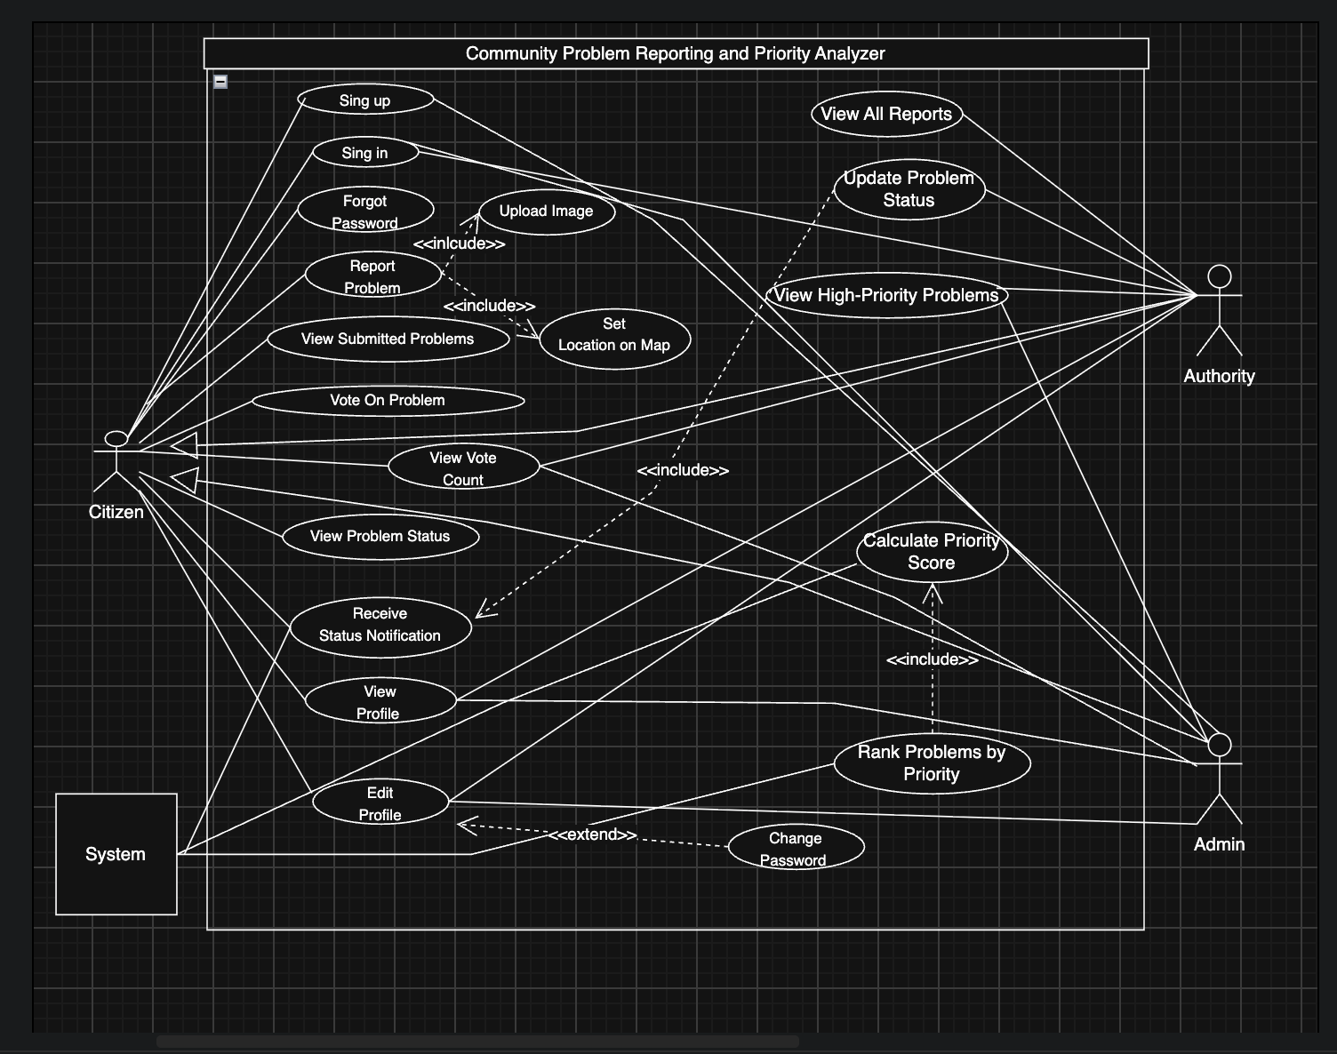

Class Diagram
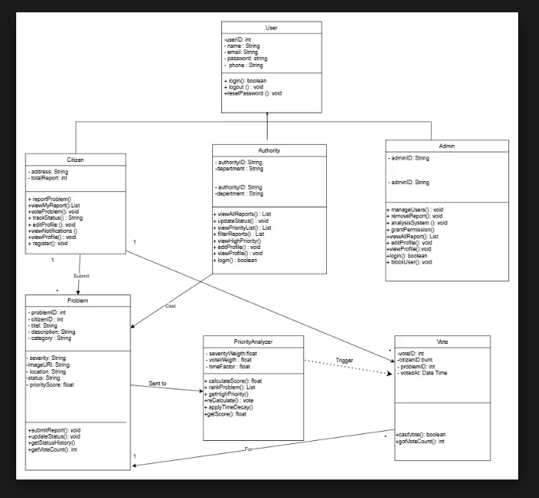

4.2 UI Design using Figma:

Community Problem Reporter & Priority Analyzer
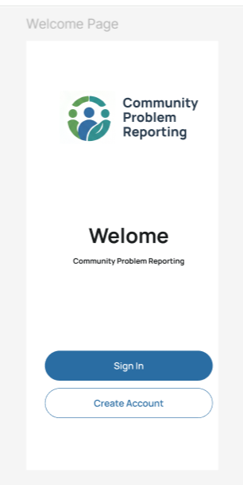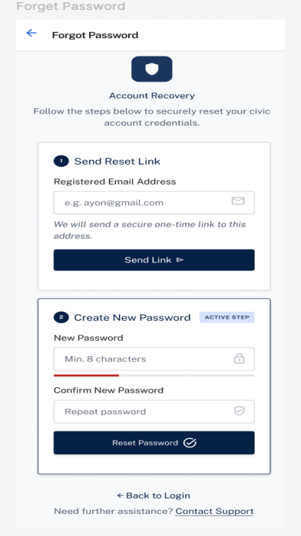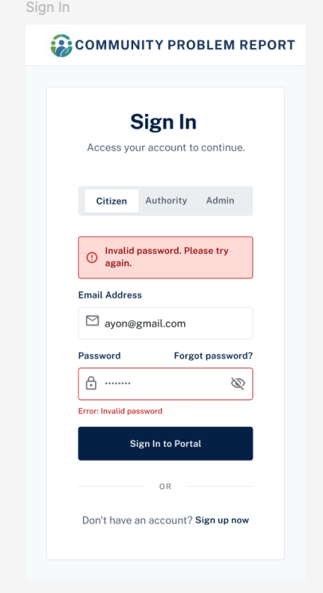
Figure: Welcome page Figure: Sign In & Role Detection Figure: Forgot Password

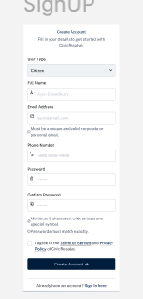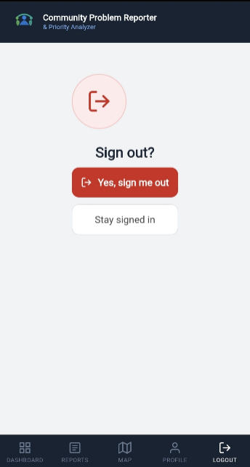
Figure : Sign UP Figure: Logout

Role : Citizen
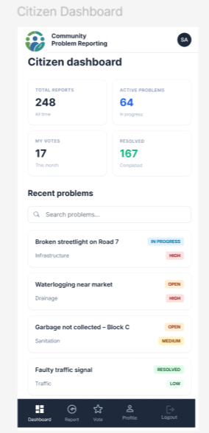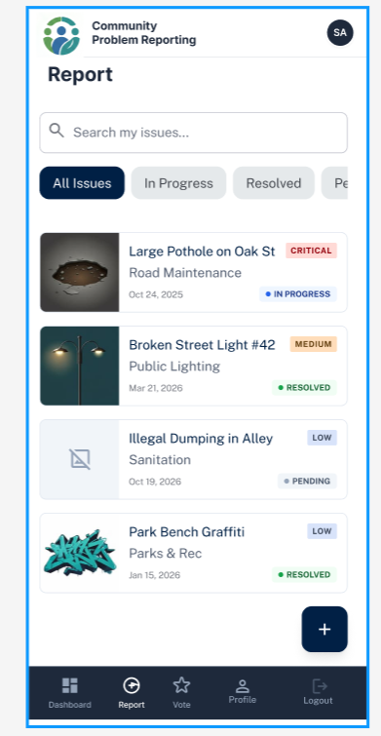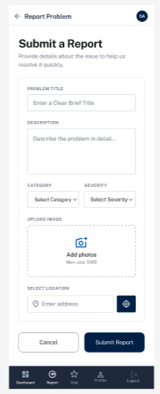
Figure: Citizen Dashboard Figure: My Reports Figure: Report Problem

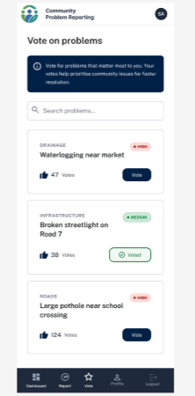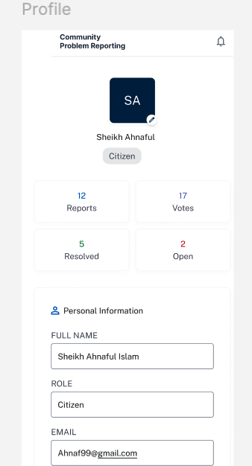
Figure: Voting Problem Figure: Profile

Role: Authority

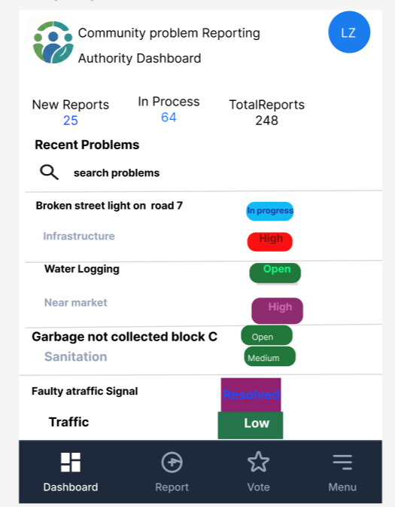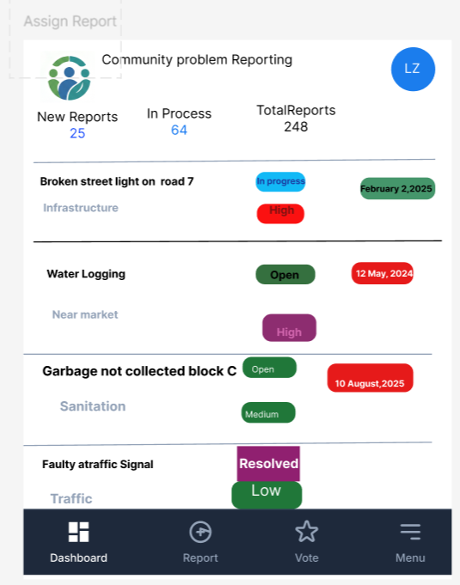
Figure: Authority Dashboard Figure: Assign Report

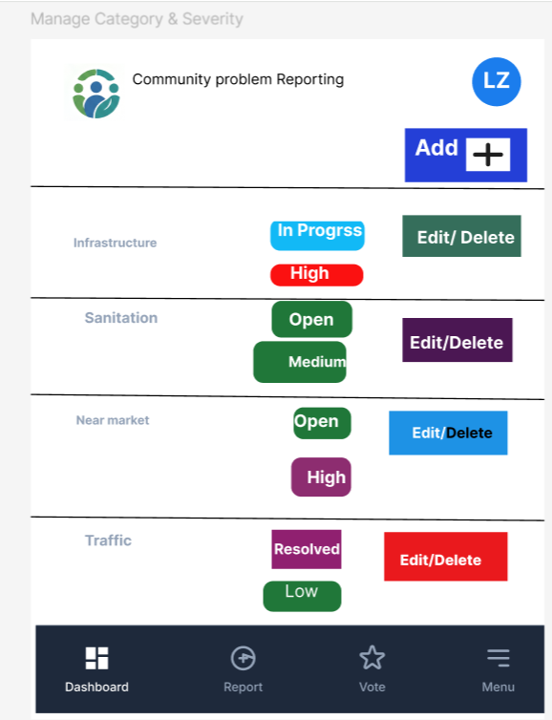

Figure: Manage Category & Severity Figure: Profile

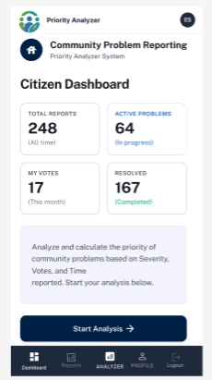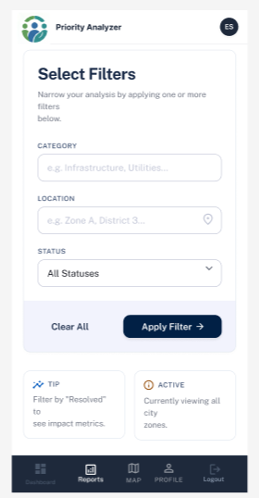
Figure: priority Analyzer ( Start ) Figure: Apply Filters
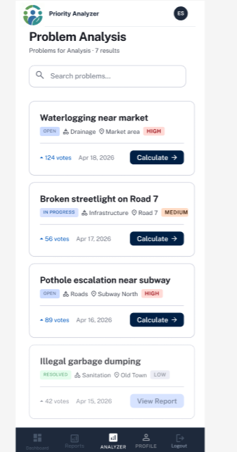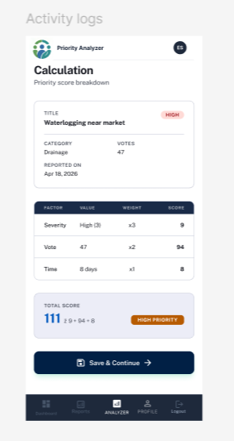
Figure: Problem Analysis Figure: Calculation
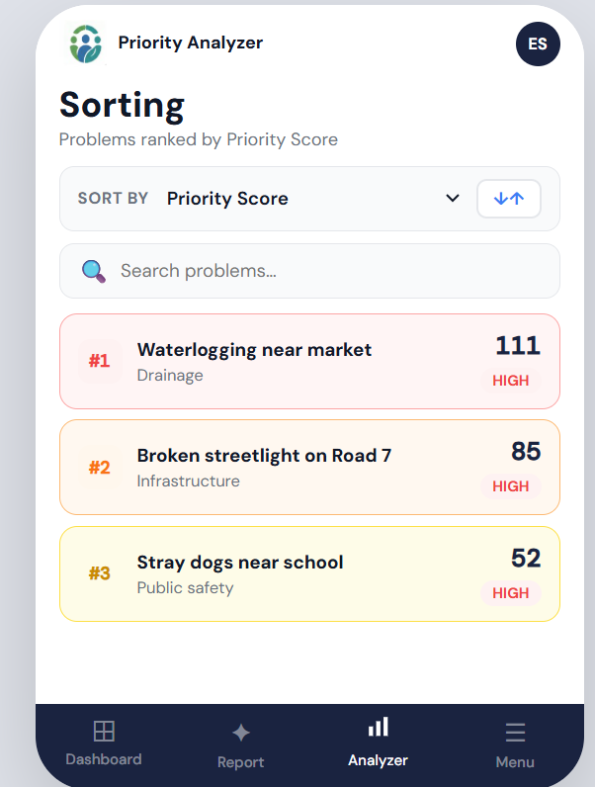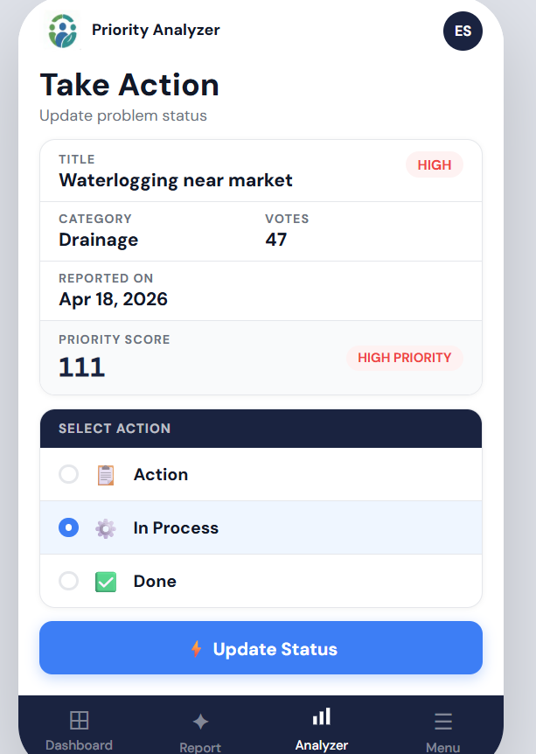
Figure: Sorting Figure: Take Action

Role: Admin
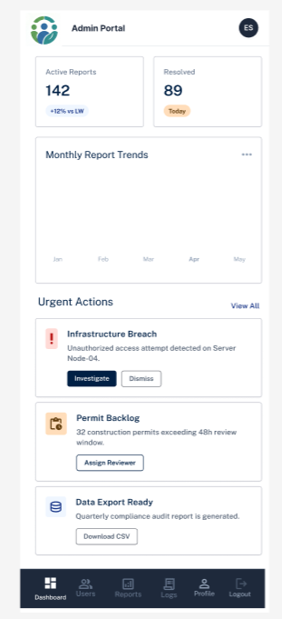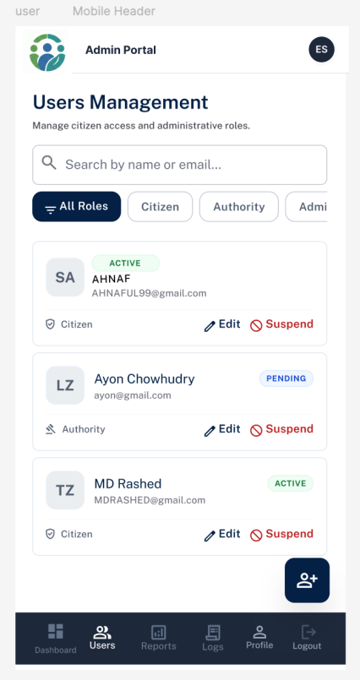
Figure : Admin Dashboard Figure: Manage Users
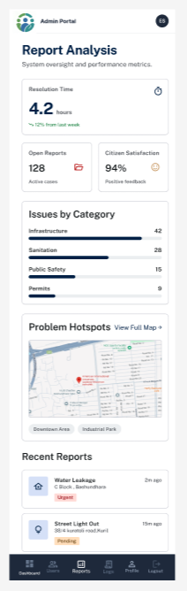 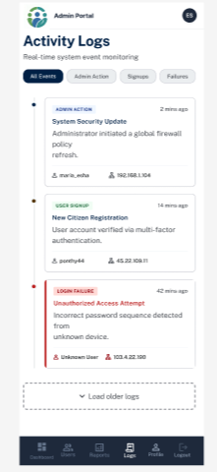 Figure: Report Analysis Figure: Activity Logs

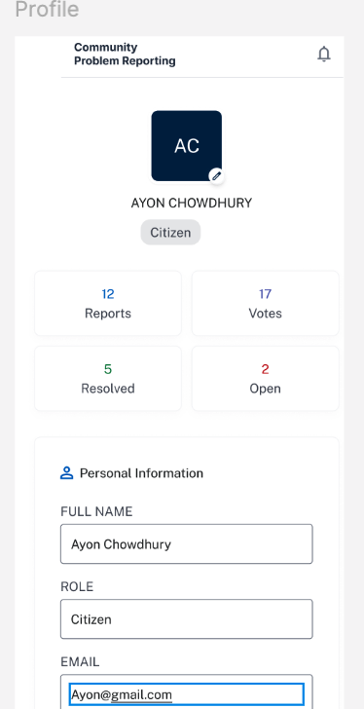
Figure: Profile
Figma Link:
https://www.figma.com/design/yoP52fYLstYVUz4dt0SLm9/Civic-Software-Group-7?node-id=0-1&t=7VrWOsn0ULQiPoJP-1

5. Git Workflow:
Git Link:
https://github.com/Axialinux/Civic-Problem-Analyzer.git

Ahnaf

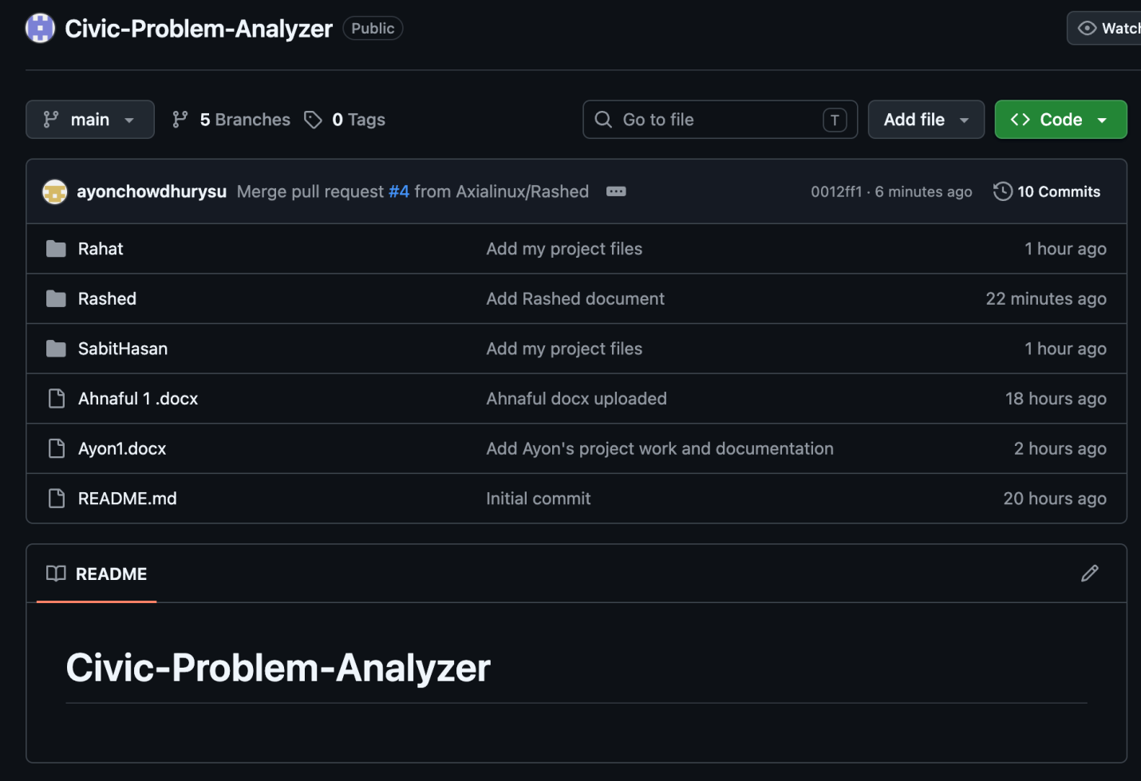

Ayon
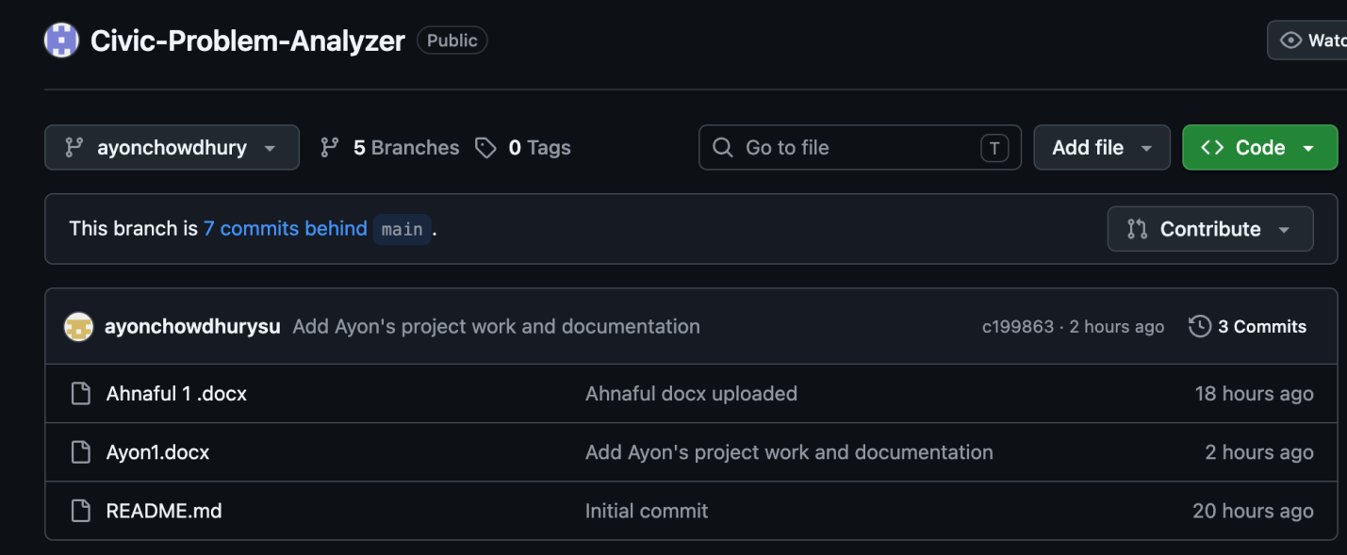
Sabit
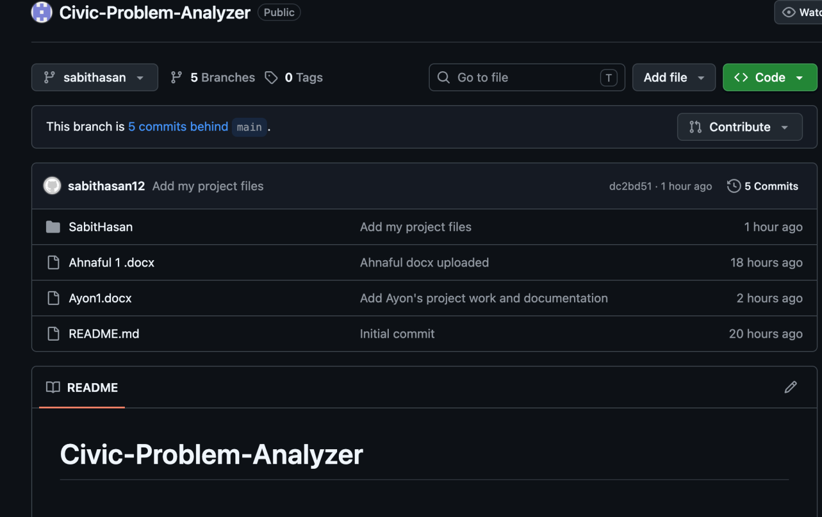

Rashed
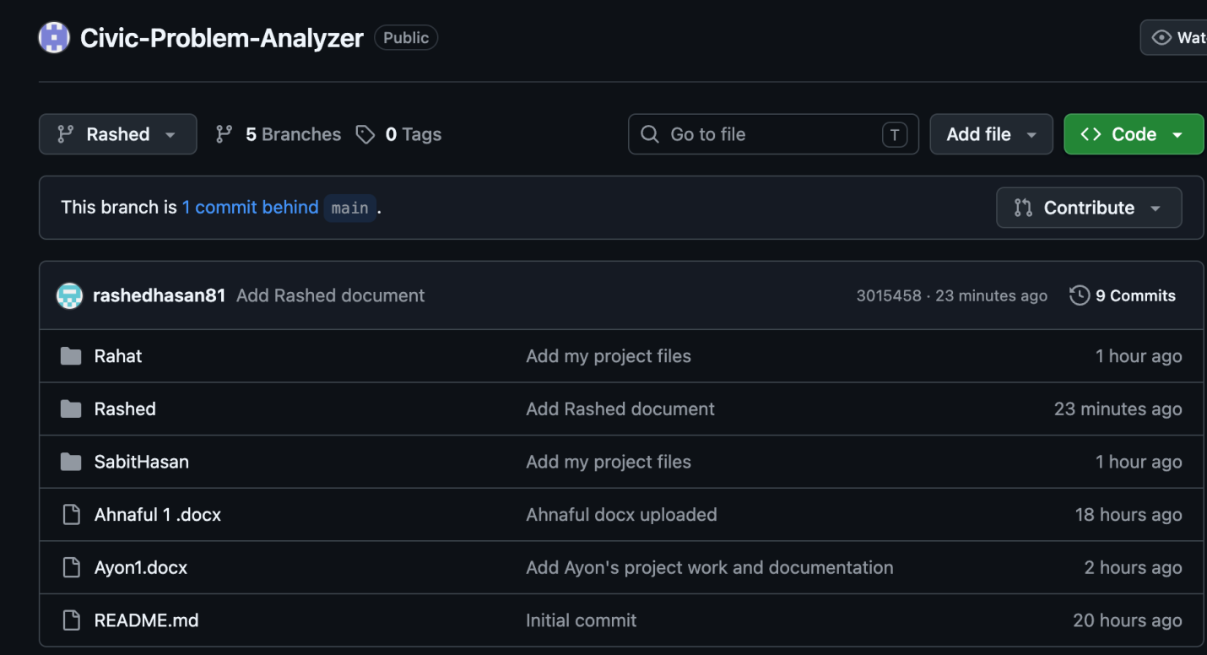
Rahat
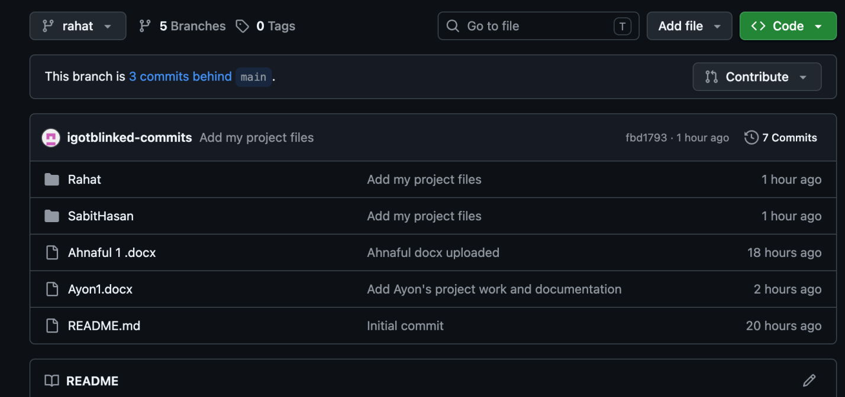

Trello
https://trello.com/b/jKOWQYcA/community-problem-reporter-and-analyzer
